Types of RVs:
- Discreet RV
  - Support is finite
  - Support is countable
- Continuous RV

Discreet Distributions

Bernoulli Distribution
- Models a random experiment with only 2 possible outcomes
- Success and Failure, X ∈ {0, 1}
- PMF:
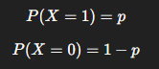

- Single trial success/failure

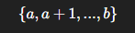
Discrete Uniform Distribution
- Support, X ∈

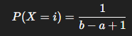
- PMF

- All values are equally likely

Binomial Distribution
- Parameters: n = experiment, p = possibility of success for each experiment
(n, p)
- Support, X ∈

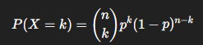
- PMF

- Interpretation: Number of successes in n independent Bernoulli trials

Geometric Distribution
- Support, X ∈ N (1, 2, 3 …)

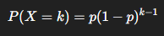
- PMF, k ∈ N

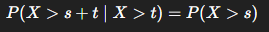
- Memoryless property. Among discrete RVs, geometric is the only one with memoryless property

- Used in Queuing theory & waiting time problems

Poisson Distribution
- Parameter, rate parameter

- Support, X ∈ N (1, 2, 3 …)

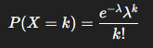
- PMF

- Count of rare events in fixed interval

Continuous Distributions
- X is continuous if there exists a non-negative function fx(x) such that:
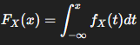

- Here fx(x) is called PDF

Uniform Distribution [a, b]
- PDF

- CDF is linear between a and b
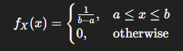

Exponential Distribution
Parameter:

PDF:

CDF:

Memoryless Property:

- Exponential is the only continuous RV with memoryless property.

Gaussian/Normal Distribution
Parameter:

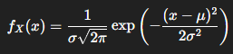
PDF:

Heavy Tailed vs Light Tailed
- Light tailed
  - Exponential
  - Gaussian
  - Probability decays fast
- Heavy-tailed
  - Cauchy distribution
  - Significant probability far from the mean

